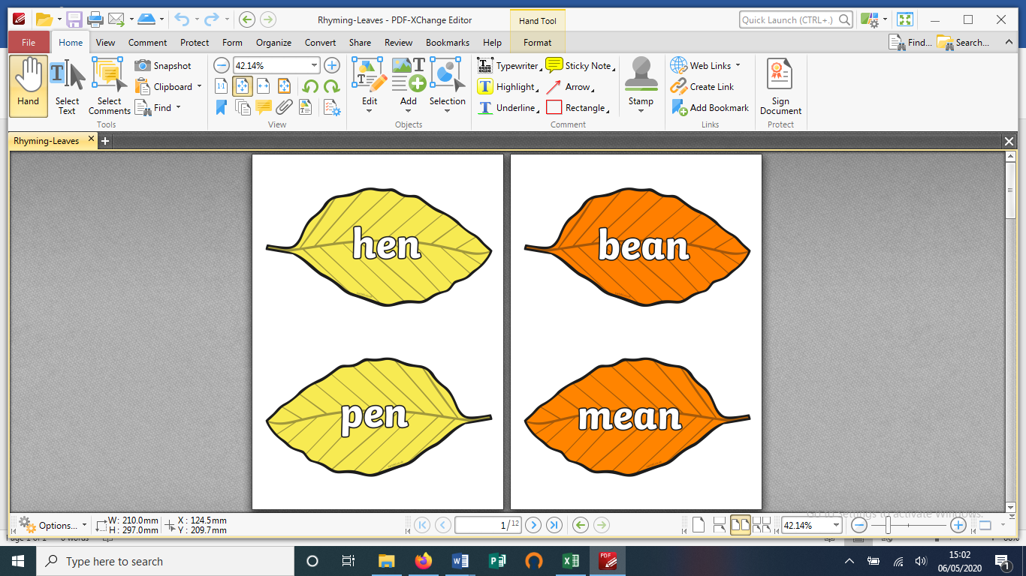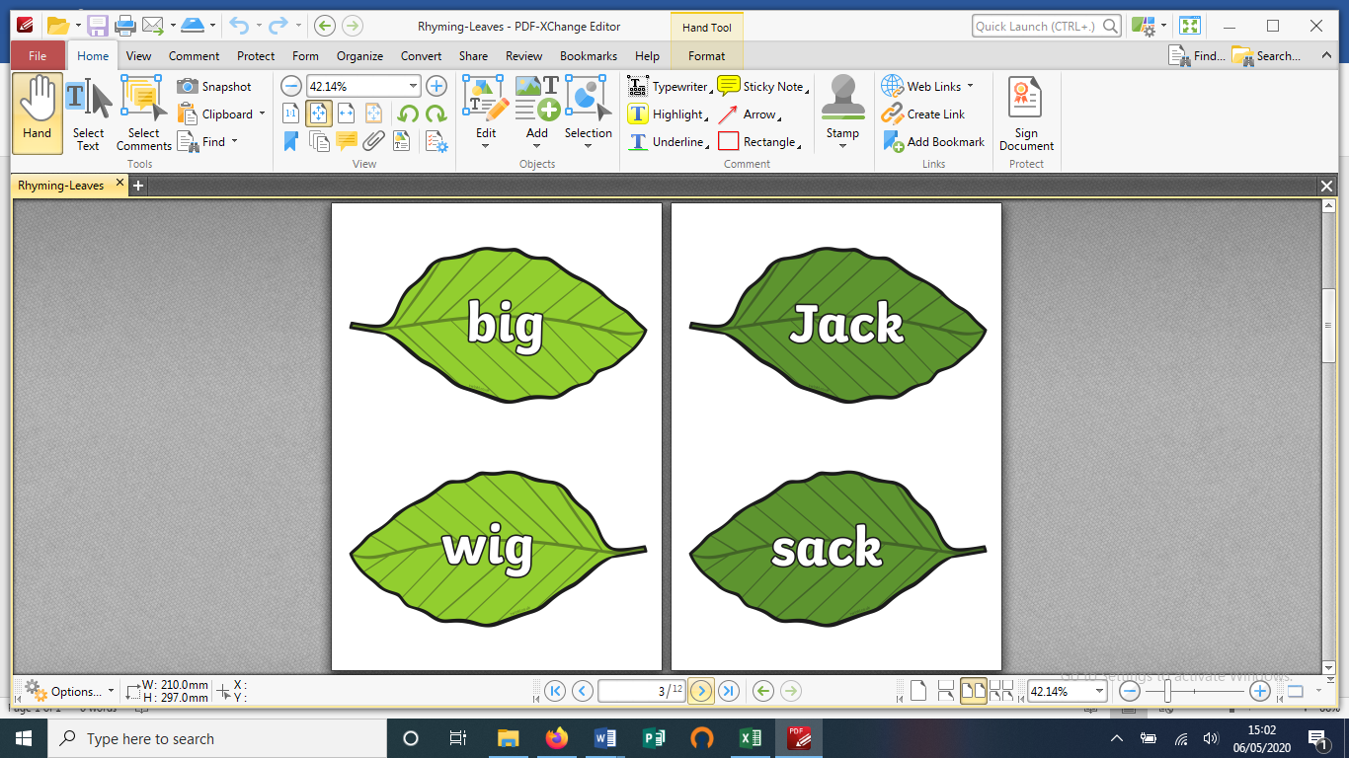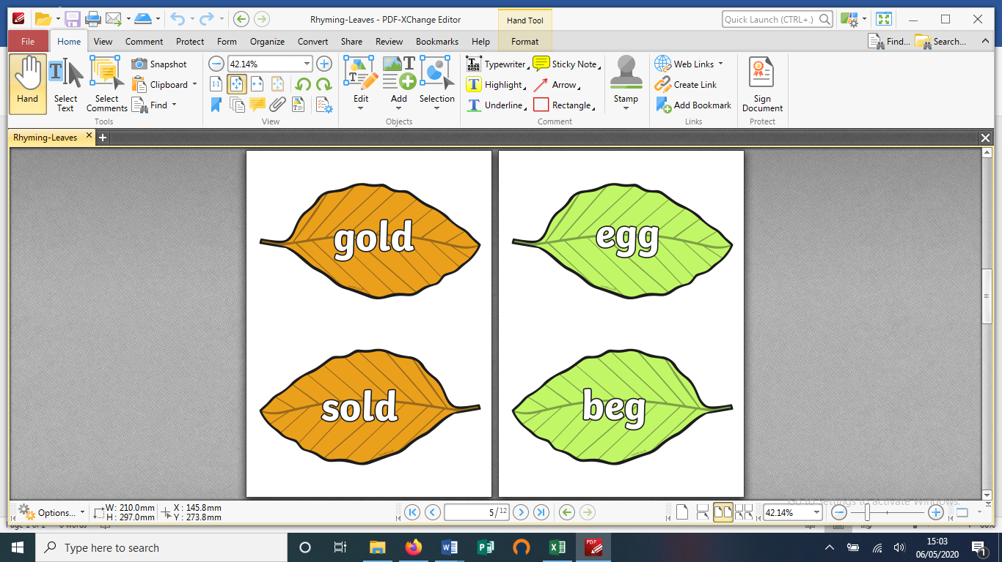

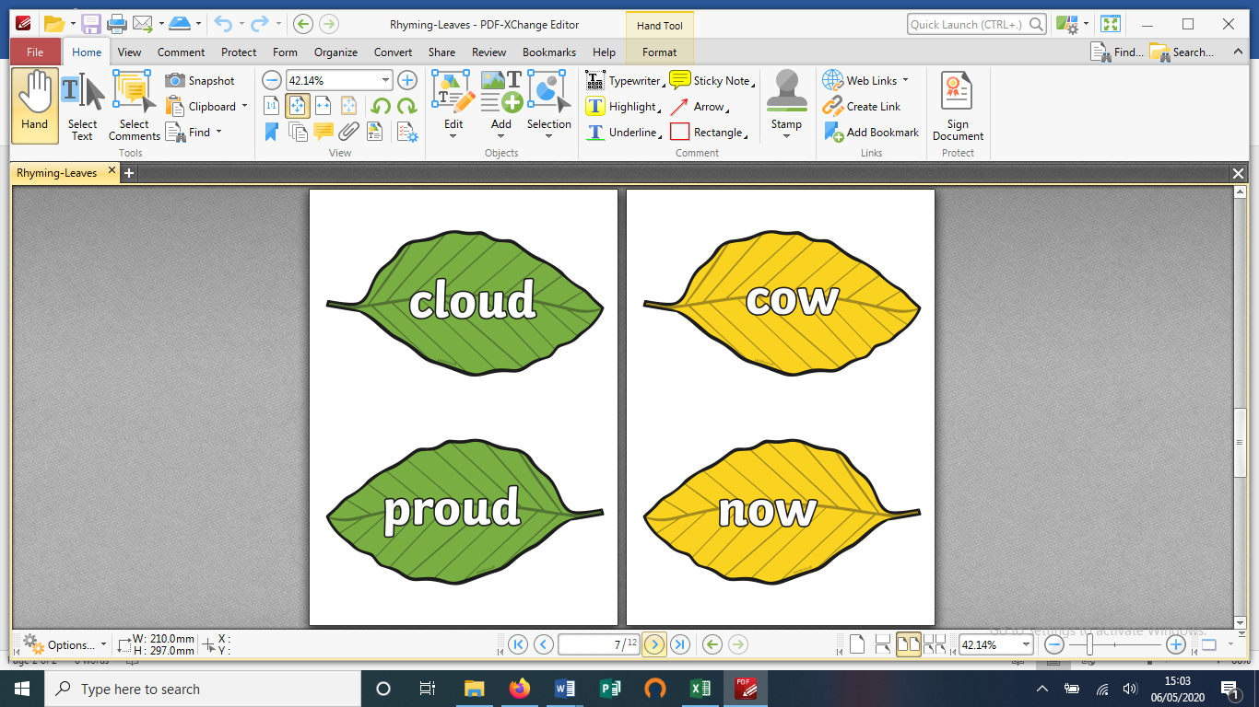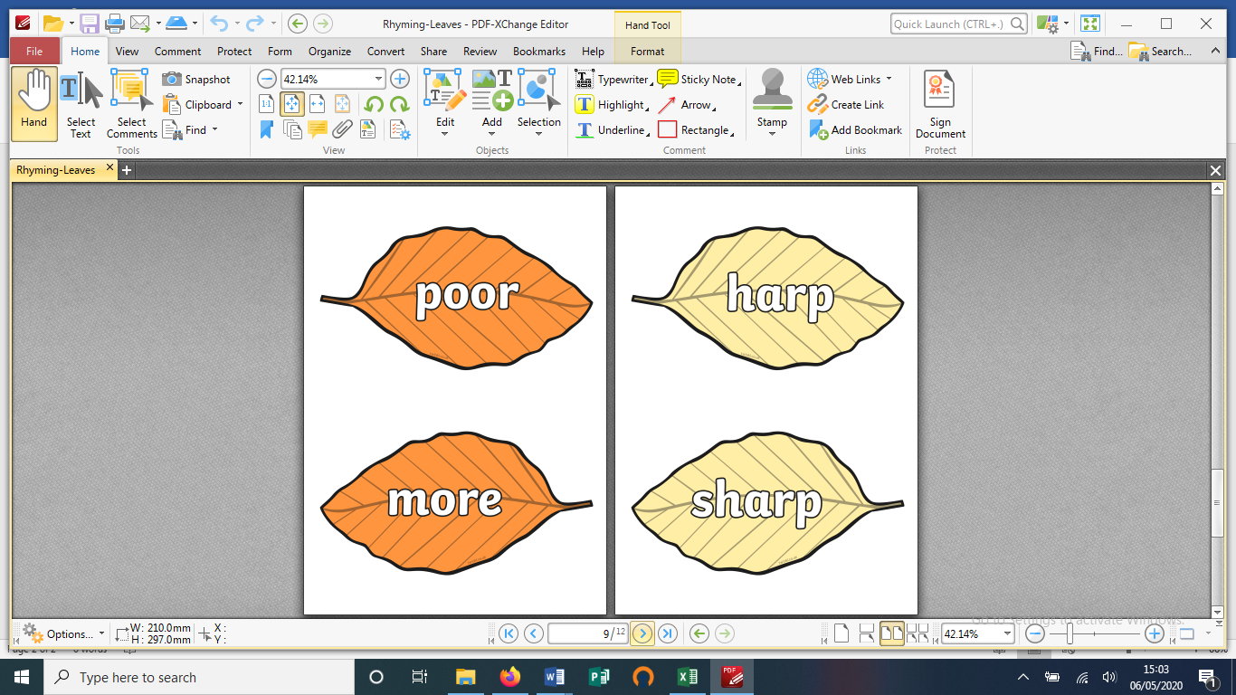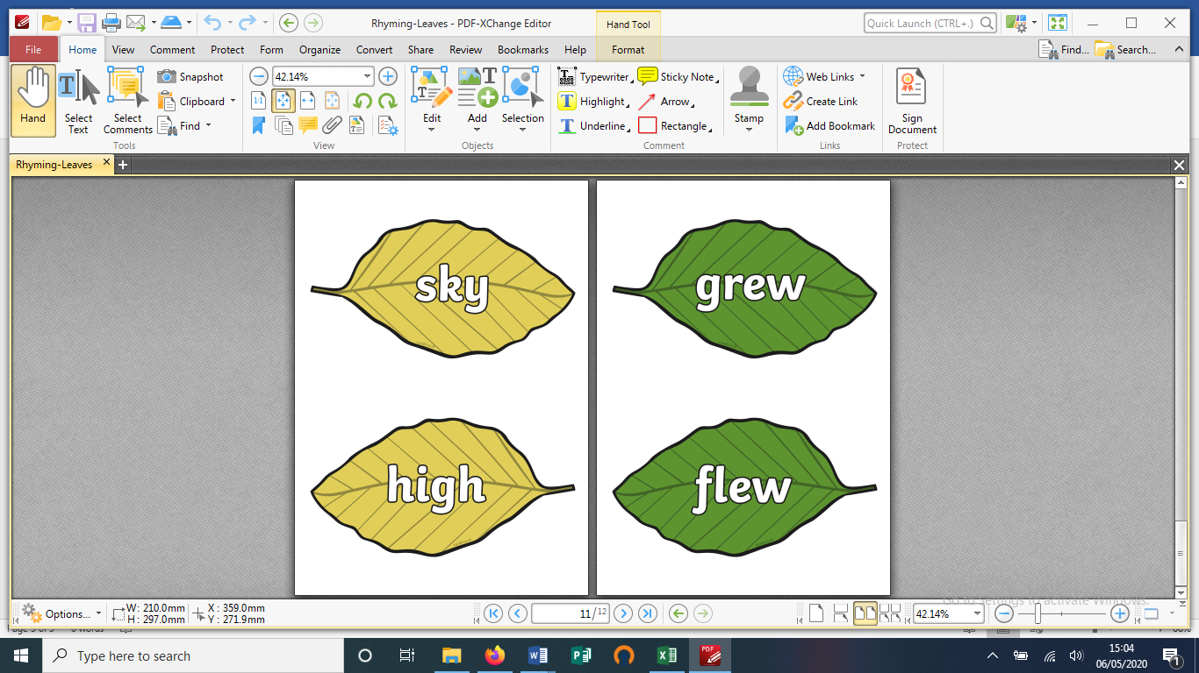

**Cut out the leaves and mix them up. Match the rhyming words and put them onto the beanstalk you have drawn. 😊**

**Send a photo of your rhyming beanstalk to** [**community@oldbrookschool.co.uk**](mailto:community@oldbrookschool.co.uk) **or upload it to Tapestry!**